**PRACTICAL QUESTIONS OF UNIT 2: ELECTRONIC SPREADSHEET (ADVANCED)**

**What are the steps to**

1. **Consolidate data from various sheets.**

Ans. i. Open spreadsheet in OpenOffice Calc.

ii. In Sheet1, type SEM1 marks. In sheet2, type SEM2 marks. In Sheet3, type SEM3 marks.

iii. Click in Sheet4 where you want to get the result.

iv. Choose DATA → CONSOLIDATE to open consolidate dialog box.

v. Click Shrink button on the right side of source data range.

vi. Click Sheet1 and select the desired range of marks. Click Shrink button to open consolidate dialog box and click on ADD button (Range will be added to consolidation ranges)

vii. Repeat the above step to add data ranges from Sheet2 and Sheet3 also.

viii. Click Shrink button on the right side of Copy result to and specify where you want to display the result by selecting the first cell of the target range. Click Shrink button to open consolidate dialog box.

ix. Select the function which you want.

x. Click More button and make sure that Row labels and column labels check boxes are checked to get row and column headings and link to source data check box should be checked so that changes can be reflected in the consolidated sheet.

xi. Click OK to consolidate the ranges.

1. **Calculate Subtotals.**

Ans. i. Open the sheet containing data.

ii. Select the range of cells to be calculated.

iii. Click on DATA → SUBTOTALS

iv. Select the column by which the subtotals need to be grouped in the GROUPBY list.

v. In the ‘Calculate subtotals for’ box, select the columns containing values that you want to subtotal(by clicking the check box).

vi. In the ‘Use function’ box, select the function that you want to use to calculate subtotals.

vii. Click ok.

1. **Analyse data(take 2-3 cases) using What if Scenarios.**

Ans. i. First type the content and the result using formula as shown below:

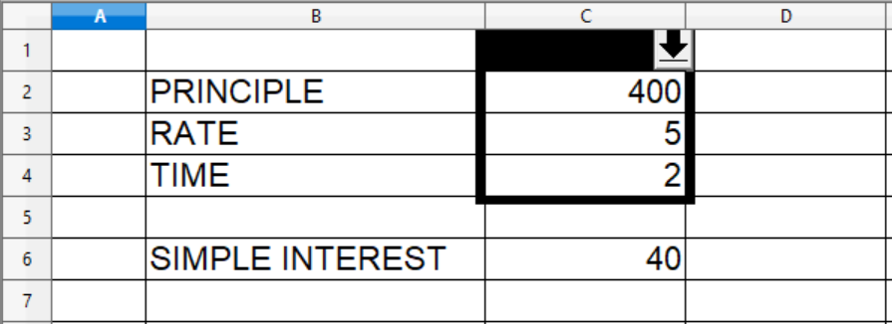

ii. Select the cells that contain the values that will change between scenarios.

iii. enter the name of the new scenario and uncheck the ‘copy back’ box.

iv. Click ok.

v. Change the value that you want to change.

vi. Select the same range in the changed worksheet.

vii. Click on TOOLS → SCENARIOS again and give name to it.

viii. Click downward arrow to select the scenario.

ix. click the scenario name to apply that scenario to the current sheet.

1. **Analyse data using What if Tools used for multiple operations for more number of cases.**

Ans. i. Type data as shown below:

1. SI is being calculated using the formula (PRINCIPLE*RATE*TIME)/100 i.e. =(c2*c3*c4)/100
2. Type various Principles in one column for which you want to calculate SI.

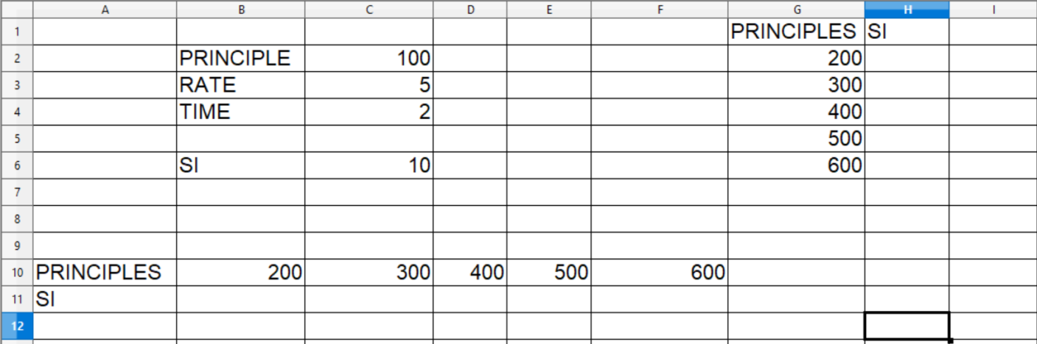

ii. Select the values of principles along with adjacent column of SI(i.e. select G2 to H6).

iii. Click DATA → Multiple Operations.

iv. Click in ‘Formulas’ box and select the value which you calculated using formula(eg. SI value in this case i.e. C6).

v. Click in ‘Column input cell’ box and select the value with which you want to exchange(eg. Principle value in this case i.e. C2) and click OK. Calculated values will be displayed.

vi. For Row input cell, Select the values of principles along with adjacent row of SI(i.e. select B2 to F11).

vii. Click DATA → Multiple Operations.

viii. Click in ‘Formulas’ box and select the value which you calculated using formula(eg. SI value in this case i.e. C6).

v. Click in ‘Row input cell’ box and select the value with which you want to exchange(eg. Principle value in this case i.e. C2) and click OK. Calculated values will be displayed.

**5. Use Goal Seek feature to get the input that would provide a given output.**

Ans. i. Type Selling Price and Cost price and Calculate Profit using the formula(i.e. =c2-c3 in the case shown below)

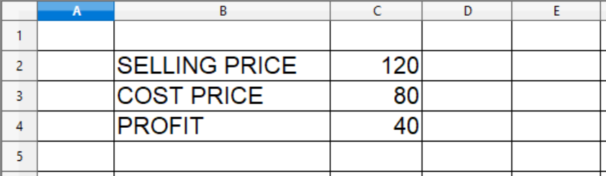

ii. Click TOOLS → Goal Seek, Goal Seek dialog box will get open.

iii. Click in the ‘Formula cell’ box and select the cell with calculated value using formula (eg. profit value i.e. C4 in this case)

iv. Click in ‘Target value’ box and write your target value(eg. write target profit you want in this case).

v. Click in ‘Variable cell’ box and select the cell which you want to change( eg. selling price value i.e. C2 in this case).

vi. It will display Goal Seek successful. Insert Result( ) into current cell? If it is the desired result, click YES button otherwise click NO button to try again.

**6. Use SOLVER to estimate the marks in 4th Semester in each of the four subjects so that the student can get distinction(75%). Assuming maximum marks is 100 and minimum marks should be 33 in each subject.**

Ans. i. Type the spreadsheet given on page no. 18 of the pdf file.

ii. Calculate SUM using the formula

Click in the cell B7 and type =SUM(B2:B5) and press enter. Copy the formula for the cells C7, D7 and E7.

iii. Calculate PERCENT in the cell B9 by using the formula

=SUM(B7:E7)/16

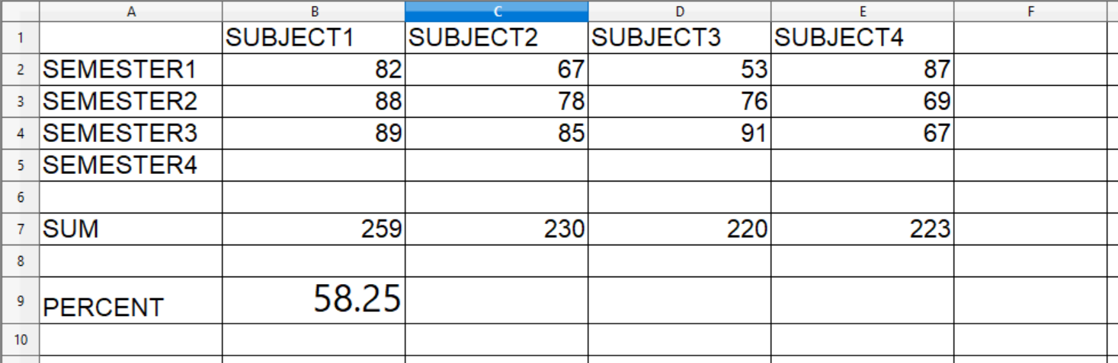

iv. Click TOOLS → SOLVER.

v. Click in the Target cell box. Select the target cell(eg. B9 in the above case) which will have the desired value.

vi. Click Optimize result to ‘Value of’ option for exact match and type 75 which you want to achieve to get distinction.

vii. Click shrink button of the ‘By changing cells’ box and select the range of cells which you want to estimate and again click shrink button.

viii. To give limiting condition, click in the cell reference box. Click in the cell whose value you want to give in limiting condition(eg. set upper limit of subject1 for semester4 i.e. $B$5 <=100).

ix. Click in the next cell reference box. Again click in the same cell to set the lower limit (i.e. $B$5 >= 33).

x. Repeat steps viii and ix for remaining three subjects and click SOLVE button.

xi. Click ‘Keep Result’ button if you are satisfied otherwise click ‘Restore Previous’ button to try again.

**7. Inserting a new sheet.**

Ans. i. Click on the sheet tab after which you want to insert a new sheet.

ii. Click on INSERT → SHEET.

iii. Click Position as eg. ‘After current sheet’

iv. Specify number of sheets you want to insert.

v. Name the sheet if you want to give different name.

vi. If you want to insert from a different file then click FROM FILE button, Click BROWSE button, select the file from which you want to insert the sheet.

vii. Check the LINK button if you want to reflect the changes of the inserted file here also.

viii. Click OK.

**8. Rename a worksheet.**

Ans. i. Double click on the sheet tab, give new name and click OK.

OR

Right click on the sheet tab and select Rename sheet, give a new name and click OK.

OR

Click the sheet tab, Click FORMAT → SHEET → RENAME,Give new name and click ok.

**9. Creating Reference to other sheets by using keyboard in OpenOffice Calc.**

Ans. For example,

i. In sheet1, in the cell A1 type 10, In the cell A2 type 20, In the cell A3 type 30.

ii. Click Sheet2, suppose in the cell D2 of sheet2, we want to calculate sum of the values of A1, A2 and A3 of sheet1.

iii. In the cell D2 of Sheet2 type =SUM(Sheet1.A1:Sheet1.A3) and press enter.

In this way we are referring to other sheet by using keyboard in OpenOffice Calc.

**10. Creating reference to other sheet by using mouse.**

Ans. Consider the same example as described above,

i. In sheet1, in the cell A1 type 10, In the cell A2 type 20, In the cell A3 type 30.

ii. Click Sheet2, suppose in the cell D2 of sheet2, we want to calculate sum of the values of A1, A2 and A3 of sheet1.

iii. In the cell D2 of Sheet2 type =SUM(

and click Sheet1 and then cell A1

=SUM(Sheet1.A1

will be displayed then click the cell A3.

=SUM(Sheet1.A1:Sheet1.A3)

will be shown, press enter or click ACCEPT button and you will get the answer.

**11. Create reference to other document by using keyboard and mouse.**

Ans. i.Open file1 (suppose the value is in the cell A3 which you want to refer)

Minimize the file1.

ii. Open file2, click the cell where you want to get the value from the cell A3 of file1 and type =

iii. click the cell A3 of file1 using mouse(Observe the formula bar to get path, filename and the cell) and press enter.

iv. If you want to create reference using keyboard then type

=’file:///path/filename’#sheetname.celladdress

where path is the path of the file which contains that sheet, filename is the name of the workbook, sheetname is the name of the sheet and cell address is that particular cell which you want to refer.

**12. Create hyperlink in a sheet.**

Ans. i. Click in the cell where you want to create hyperlink.

ii. Click INSERT → HYPERLINK →DOCUMENT.

iii. Click Select Path button, select the file which you want to open and click OPEN button.

iv. Click ‘Target in Document’ button to specify that particular sheet which you want to open.

v. Click in the Text box in Further settings and type the text which you want to display as hyperlink text.

vi. Click APPLY button and click CLOSE button.

vii. Take your mouse pointer to the hyperlink text, your mouse pointer will change to a hand.

viii. Click the hyperlink to observe the creation of hyperlink in a sheet.

**13. Edit hyperlink in the sheet.**

Ans. i. Click one cell before the cell where you have made hyperlink.

ii. Use arrow key to move to the cell with hyperlink.

iii. Click Hyperlink button.

iv. Do the editing or corrections which you want.

v. Click APPLY button, then click CLOSE button.

**14. Remove hyperlink from the sheet.**

Ans. i. Right click on hyperlink.

ii. Select ‘Default Formatting’ to remove hyperlink.

**15. Link to External data in the spreadsheet.**

Ans. i. Open file1 and enter data, select the range of data, Click INSERT →NAMES → DEFINE. Give name of the range, click OK and save the file.

ii. Open file2, Click INSERT → Link to External Data.

iii. Click Browse button to get URL of external data source, Select the file and click OPEN button.

iii. Available tables/ranges will be shown, Select the range which you want to link.

iv. Check the Update Every box, Set time to 5 seconds and click OK.

v. Open both the files, file1 and file2 side by side to view the updates.

vi. Update in file1 and save file1, observe the updated data in file2 after 5 seconds.

**16. Link the worksheet to registered data source.**

Ans. i. Open your spreadsheet where you want to link the registered data source(eg. File1.ods).

ii. Click FILE →NEW → DATABASE .

iii. ‘Create a new Database’ is already clicked, click NEXT button.

iv. ‘Yes, register the database for me’ is already clicked, click FINISH button.

v. Give name to your newly created database(mydatabase.odb) and click SAVE button.

vi. mydatabase.odb will get open.

vii. Under ‘Database’, Tables is already selected. Select ‘Use wizard to create Table…’ under Tasks bar.

viii. Select category of the table(eg. Personal)

ix. Select any one table from the sample tables(eg. Library)

x. Select the fields of your table from the available fields and click > button to add the desired field in the list of selected fields.

xi. Click FINISH button after selecting the desired fields.

xii. Library table will get open, enter two records, save and close library table.

xiii. Close mydatabase.odb also.

xiv. Your spreadsheet File1.ods is opened.

xv. Click TOOLS → Options → OpenOffice Base → Databases.

xvi. Select your database (i.e. mydatabse.odb) and click ok. Database has been linked.

xvii. To see your database, click Datasources button.

xviii. Open your database by clicking on it.

xix. Click Tables button.

xx. Click your newly created table(i.e. Library)

xxi. Library table will be displayed. Select the table.

xxii. Click in the spreadsheet where you want to insert the table. Click ‘Data to Text’ button to insert the table in your spreadsheet.

**17. Set up a spreadsheet for sharing**.

Ans. i. Open the spreadsheet.

ii. Click **TOOLS → Share Document**.

iii. Share Document dialog box will be displayed as shown below:

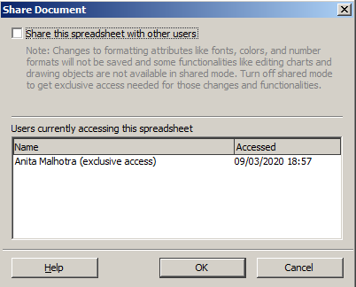

iv. Check the box prior to ‘Share the spreadsheet with other users’ and click OK.

v. The dialog box shown below will be displayed.

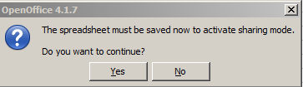

vi. Click **Yes**.

vii. **(shared)** will be displayed in the title bar along with the name of the spreadsheet as shown below.

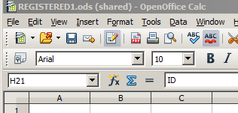

**18. Open a shared spreadsheet.**

Ans. i. Right click on the spreadsheet icon.

ii. Click **Open with → OpenOffice Calc**.

**19. Saving a shared spreadsheet.**

Ans. CASE 1. If the document was not modified and saved by another user since you opened it, the document is saved.

CASE 2: If the document was modified and saved by another user since you opened it, one of the following events will occur:

i. If the changes do not conflict, the document is saved, the dialog box displaying ‘Your spreadsheet has been updated with changes saved by other users’ as shown below is displayed.



and any cells modified by other user are shown with a red border.

ii. If the changes conflict, the Resolve Conflicts dialog box displaying ‘There are conflicting changes in this shared spreadsheet. Conflicts must be resolved before saving the spreadsheet. Keep either own or other changes’ as shown below is displayed.

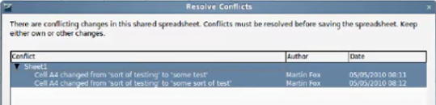

You must decide for each conflict which version to keep, yours or the other person’s. When all conflicts are resolved, the spreadsheet is saved. While you are resolving the conflicts, no other user can save the shared spreadsheet.

**20. How to remove the spreadsheet from shared mode (so that editing can be allowed)**

Ans. i. Open the shared spreadsheet.

ii. Click **TOOLS → Share Document**.

iii. Share Document dialog box will be displayed as shown below:

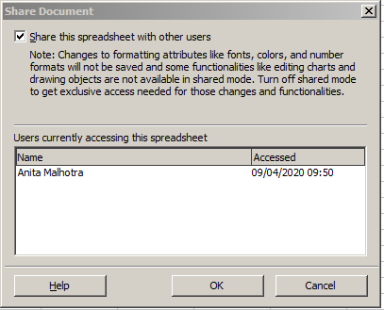

iv. **Uncheck** the box prior to ‘Share the spreadsheet with other users’ and click OK.

v. The dialog box shown below will be displayed.

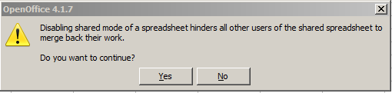

vi. Click **Yes** button.

vii. **(shared)** will be removed from the name of the spreadsheet displayed in the title bar as shown below:

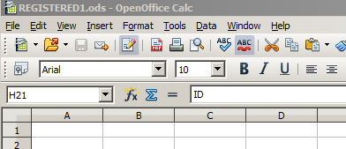

**21. Record changes in the spreadsheet.**

Ans. First make sure your spreadsheet should not be shared to record changes. If it is shared, perform the steps given in Ques. 20 to remove the spreadsheet from the shared mode.

If the spreadsheet is not shared then perform the following steps:

i. Click **Edit → Changes → Record**.

ii. Change any cell content.

iii. Hover mouse pointer on the changed cell to see the last change.

**22. Add, Edit and Format the comments.**

Ans. To **add comment** the steps are as follows:

i. Right click on the cell where you want to add comments and Select **Insert** **Comment** option.

**OR**

Click in the cell where you want to insert comment and Click **INSERT** **→ COMMENT**.

**OR**

Click in the cell where you want to insert comment and press **Ctrl+Alt+C**.

ii. Type the comment and click anywhere outside the comment box when you finish typing comment.

To **edit the comment** the steps are as follows:

i. Right click the cell whose comment you want to edit.

ii. Select Insert Comment option and do the editing whatever you want and click anywhere outside the comment box when you finish editing comment.

To **format the comment** the steps are as follows:

i. Right click the cell whose comment you want to format.

ii. Select Insert Comment option.

iii. Select the text of the comment and do the formatting whatever you want and click anywhere outside the comment box when you finish formatting comment.

**23. Review changes - VIEW, ACCEPT or REJECT changes.**

Ans. i. Open the spreadsheet.

ii. Change the content of the cell.

iii. Click **EDIT → CHANGES → ACCEPT or REJECT**

iv. Accept or Reject Changes dialog box will get open as shown below:

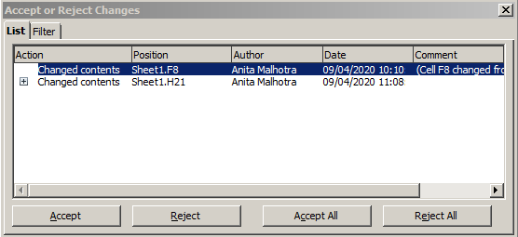

v. Click + button to **view** all changes.

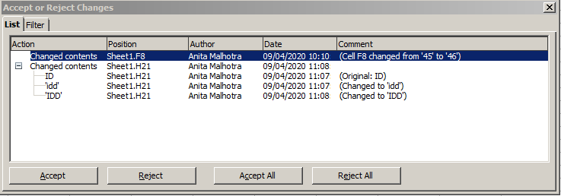

vi. Click the changed content and click Accept/Reject/Accept all/Reject all depending on your requirement and close Accept or Reject changes dialog box.

**24. Merge and Compare sheets.**

Ans. i. Open a new spreadsheet(eg. COMP1.ods) and type 10,20,30,40 and 50 in A1 to A5 respectively as shown below and save this spreadsheet:

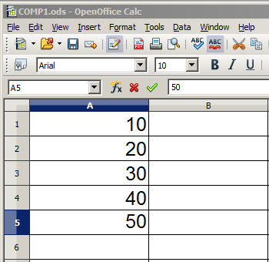

ii. Change the cell A4 content from 40 to 400 and the cell A5 content from 50 to 500. Save this spreadsheet with the name as COMP2.ods

iii. Now, you are in Comp2.ods. Click **EDIT → Compare Document**. Insert the file name by selecting the file with which you want to compare Comp2.ods(eg. Comp1.ods in this case) and click **OPEN** button.

iv. **Accept or Reject changes** dialog box will appear as shown below:

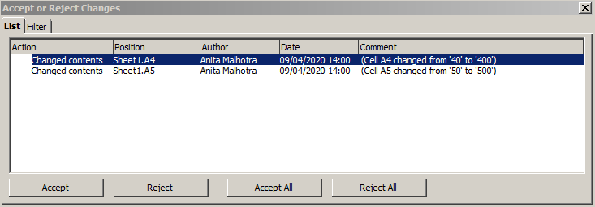

v. Select the changed content and click Accept/Reject/Accept All/Reject All depending on your requirement.

vi. Close Accept or Reject Changes dialog box after you merged both the files.

25. How can we record a Macro?

Ans. The steps are as follows:

(i) Type data in sheet 1, 2 and 3.

(ii) Goto TOOLS menu → MACROS → RECORD MACRO.

(iii) Go to the desired cell where you want to write the formula. Type =B2+B3+B4+B5

(iv) Click Stop Recording.

(v) Click on your spreadsheet.

(vi) Click on New Library.

(vii) In Library1, click Module1.

(viii) Give macro name(eg. TOTAL). Click SAVE.